**MongoDB ASSIGNMENT 1**

**1.Create a new database called student_management.**

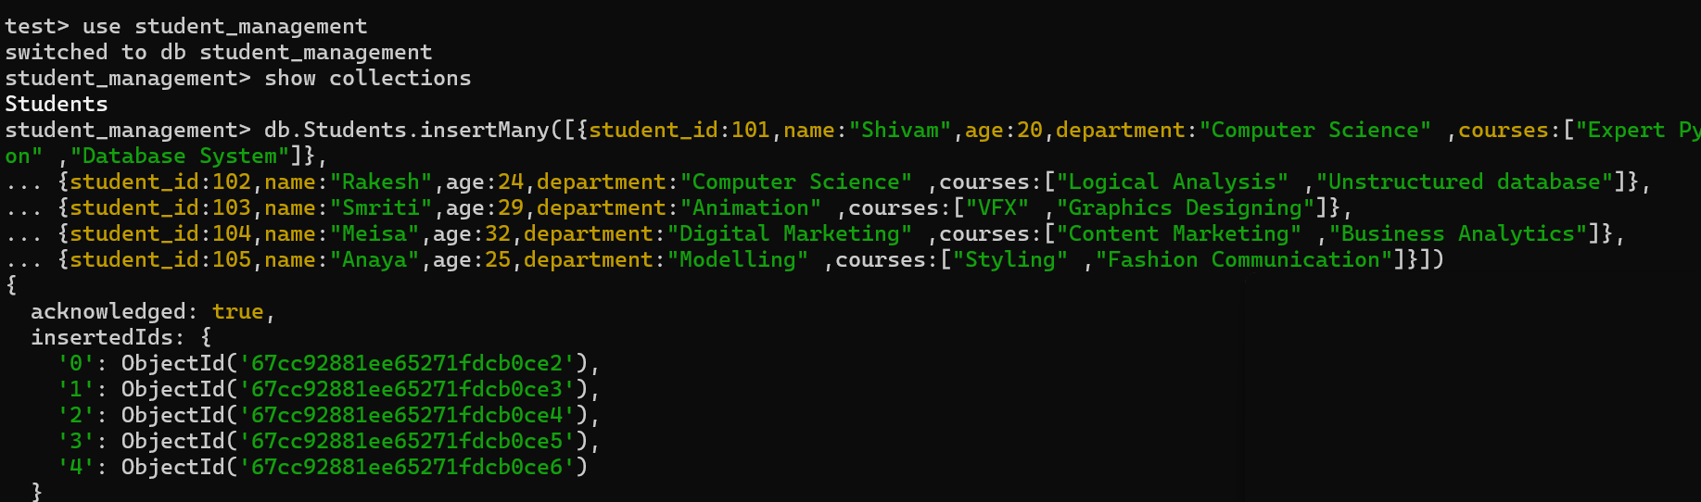

**2. Create a collection called students in the student_management database.**



**3. Insert at least five student records into the students collection.**

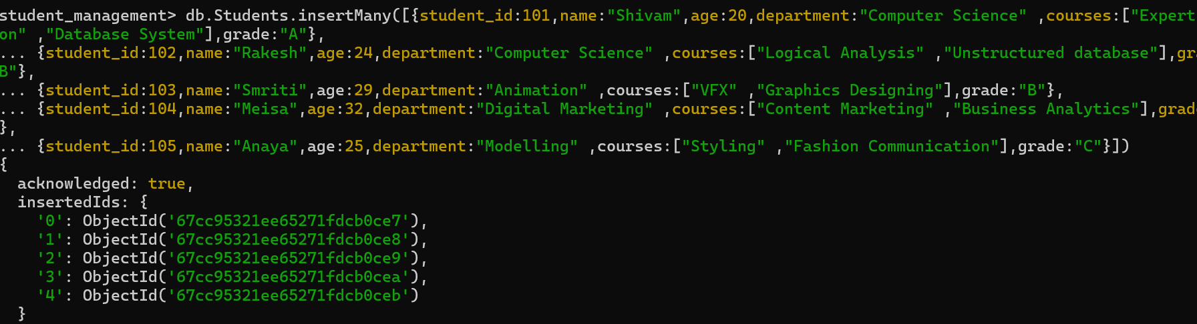

**● Retrieve all students who are in the "Computer Science" department.**

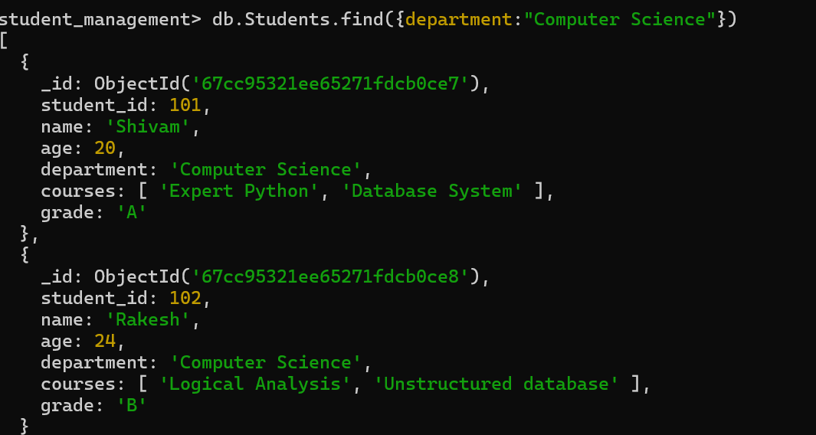

**● Retrieve students who have an age greater than 21.**

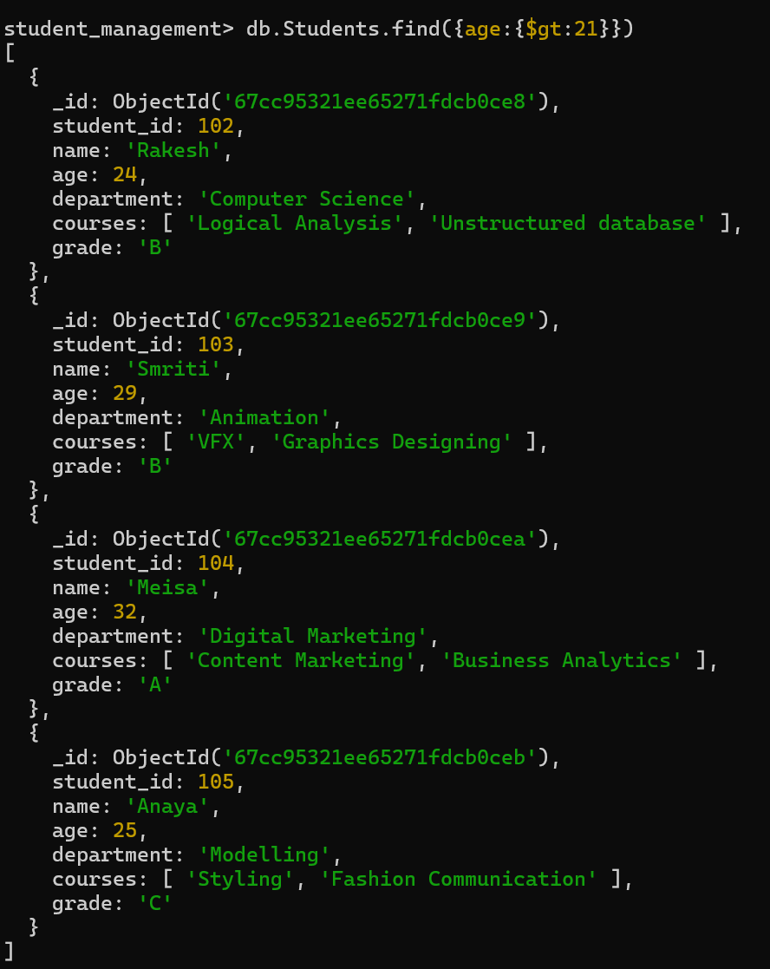

**● Retrieve students who are taking the "Database Systems" course.**

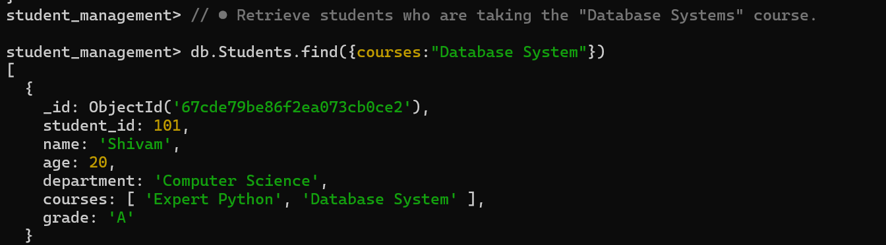

**● Retrieve students with a grade of "A".**

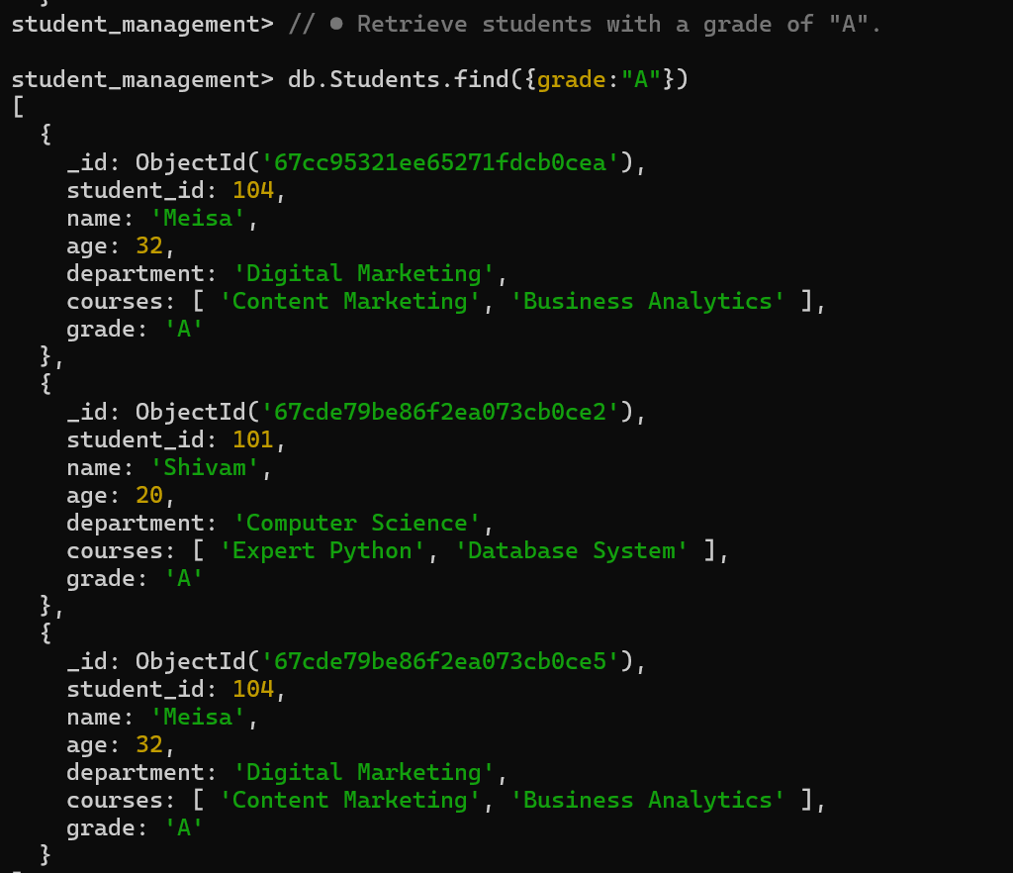

**● Update the age of a student with student_id 101 to 21.**

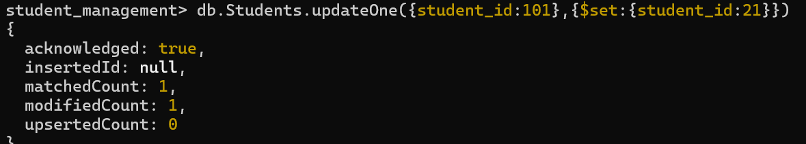

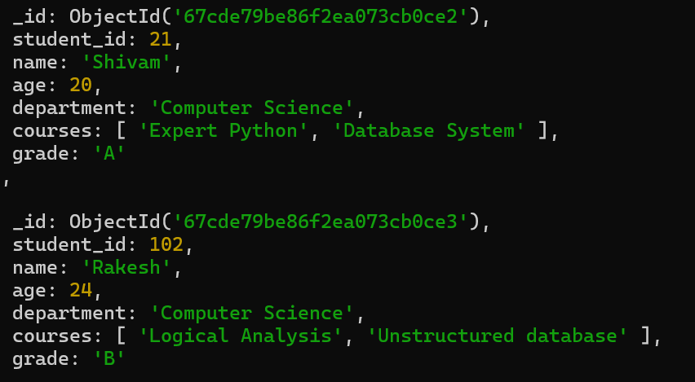

**● Add a new course, "Machine Learning", to the courses array for students in the "Computer Science" department**

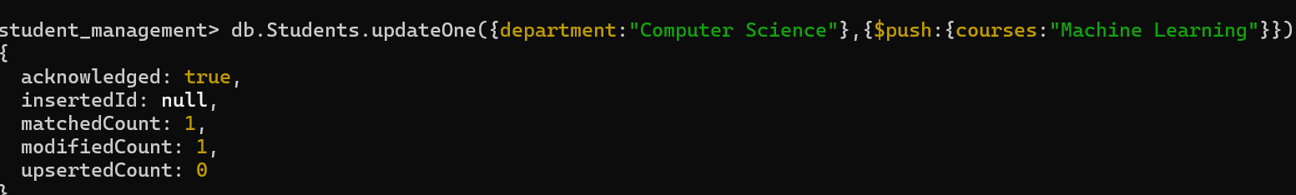

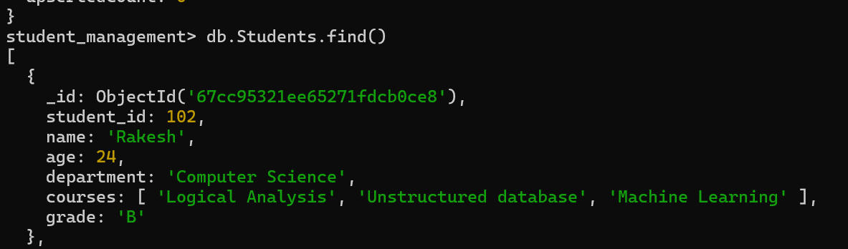

**● Delete a student record with student_id 105.**

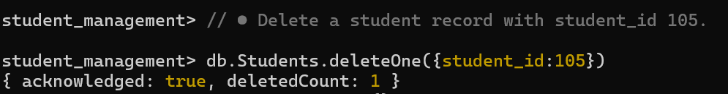

**● Delete all students who have a grade lower than "C".**

